Epilog Laser - Guide
Computer password is: Education
1. Design: Quick Overview
Use adobe illustrator to create your design. | The software is available in the self-serve menu.

In Adobe Illustrator...
1. FILE - NEW  Select file and new, to create a document. Enter the size of your document. The maximum size is 18" wide by 12" high. | 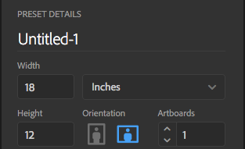
2. VIEW ~ RULERS ~ SHOW RULERS  Select VIEW~RULERS ~SHOW RULERS to show the rulers on the side of the screen. This is very helpful for precisely placing items in your design. | 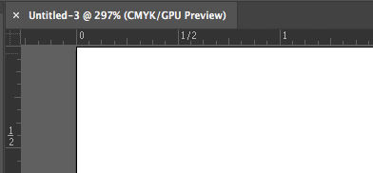
3. FILE ~ PLACE  To place an .jpg .pdf image/logo in your design, go to FILE ~PLACE.  Tip - Click on the corner square of your image and hold the shift key if you wish to resize and keep the proportions. | 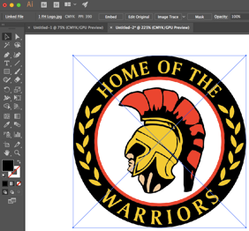
4. OBJECT ~ RASTERIZE  To transform your object in black and white for rasterizing (engraving),in the menu go to OBJECT ~ RASTERIZE and select grayscale in the color model option. | 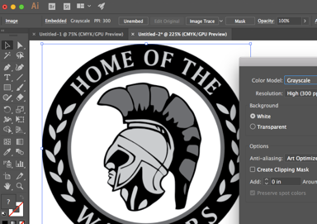
5. OBJECT ~ IMAGE TRACE
You can also adjust the various tones of your image by using OBJECT ~ IMAGE TRACE or select from the top bar - this is useful for removing the grey areas from your image
- To trace and cut inside an image do Image Trace and - EXPAND converts tracing results into paths that you can cut
________________________________________________________________________________________________________________________________________________________________________________________________________________________________________________________________________________________________________________________________________________________________________________________________________________________________________________________________________________________________________________________________________________________________________________________________________________________________________________________________________________________________________________________________________________
6. Adding a Shape - Contour line  Adding a contour line around your object  Select the tool from the menu to your right , If you press option key at the same time, it will change the shape. make your shape transparent by selecting , make your stroke color black and adjust the thickness of your stroke. *** if you want a vector cut (cut your wood right through) set your stroke width to .001. *** | 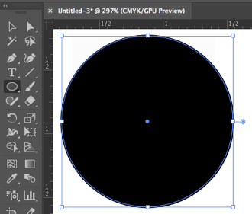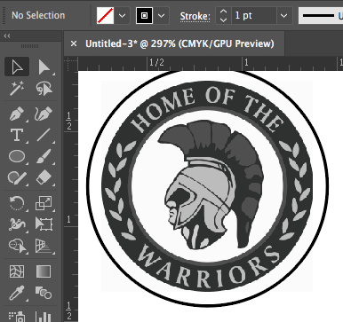
7. FILE ~PRINT  On the menu select FILE ~ PRINT. In this menu, select  default in the print preset, then select the placement at the top left corner. This is very important.  This will change the print preset back to custom.  Select Print.  An error message will appear, this is normal. Press OK. | 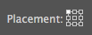  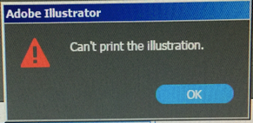

________________________________________________________________________________________________________________________________________________________________________________________________________________________________________________________________________________________________________________________________________________________________________________________________________________________________________________________________________________________________________________________________________________________________________________________________________________________________________________________________________________________________________________________________________________
________________________________________________________________________________________________________________________________________________________________________________________________________________________________________________________________________________________________________________________________________________________________________________________________________________________________________________________________________________________________________________________________________________________________________________________________________________________________________________________________________________________________________________________________________________
____________________________________________________________________________________________________________________________________________________________________________________________________________________________________________________________________________________________________________________________________________________________________________________________________________________________________________________________________________________________________________________________________________________________
2. Printing: Quick Overview

Open the Epilog Application from the start menu or from the dock.

These are all of the past jobs. Scroll up to find your job. Double click on your job. The "Job Information Window" will appear.
Job Information Window  Select Auto Focus ON (it is on by default). Click on the blue folder at the bottom left to select the material settings. | 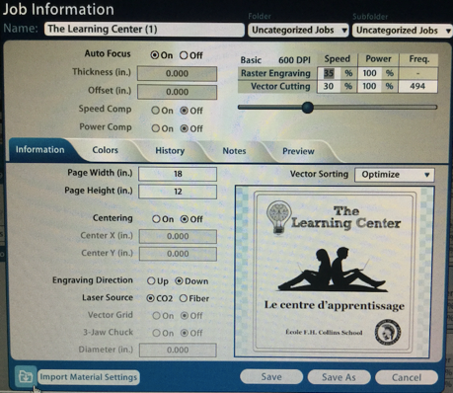
Select the material you will be printing on (aluminum, wood, glass, plastic, ...). Click on SAVE. The "Job Information Window" will appear, click SAVE. This will bring you back to the initial job menu.
With your job selected in blue, you can click on the PRINT PREVIEW icon.  Here you can select COMBINED, RASTER, VECTOR, Here you can decide to print just the Raster (engrave) or just the Vector (cut).  Click SAVE to make the changes. | 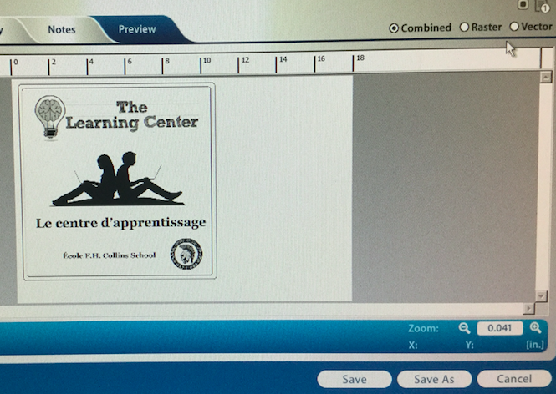

_______________________________________________________________________________________________________________________________________________________________________________________________________________________________________________________________________________________________________________________________________________________________________
Operating the Machine

Turn on the Epilog Laser - black switch just beside the power cord | 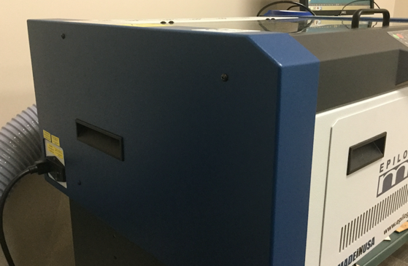
Turn on the air compressor. If you don't do this step your project will literally catch on fire. | 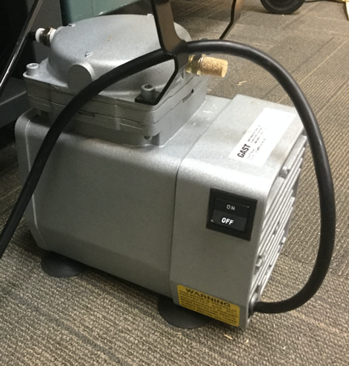
Turn on the air filter. Press the red power button and press the + to ensure that the filter is at the maximum speed.  Or If your system is using the exhaust extractor, be sure to vent directly out a window where there is no outdoor traffic. | 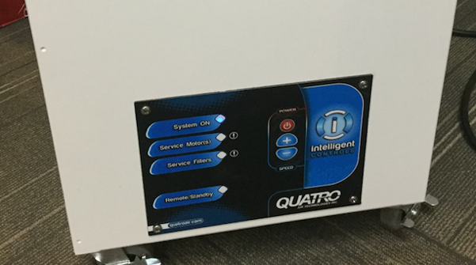
Place your material on the print bed. Your material needs to be placed right up against the numbered ruler in the top left corner and over the small aluminum lip.  Other options are available but this is a great place to start. | 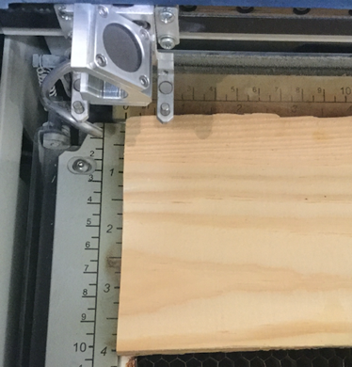
Only now you can press print  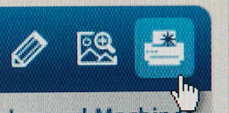  Your job will appear on the EPILOG machine menu, press the green go button | 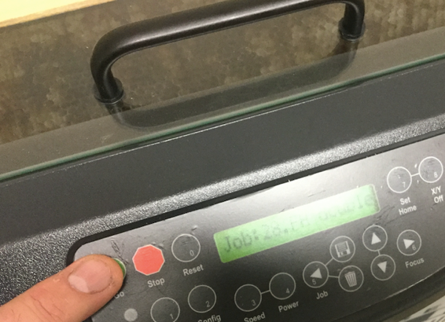

Trouble Shooting
1. If you notice that the laser head jams against the print bed ...  - material is too tall or stopped a job and it did not adjust properly | Open the bottom and move the belt to lower the tray.
2. Your vector lines did not cut, even though you set them at .001 in Adobe Illustrator  A) in print preview, you might have selected only raster - click on the vector to see if the vector lines appear. If your vector lines appear, reprint your job with only the vector lines  B) If your vector lines are not there, then go back into Adobe Illustrator, open your file, delete all elements that are raster and keep only the vector lines, go through the printing process again selecting vector in the print preview.  This should correct the problem. | 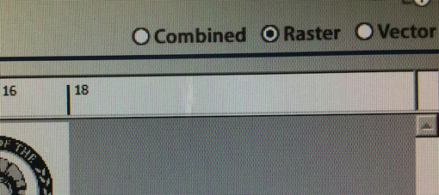
3. I had this issue. I noticed that my designs were printing oddly and that the laser seemed to be hitting the end of the track with a thump noise.  I cleaned the optical strip very carefully and it fixed the problem. I also cleaned the lens and mirror. Follow instructions in the guide. | 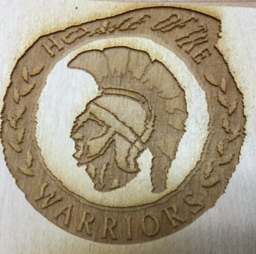
3. If you are printing on an iPhone or iPad, measure carefully where you are printing on the device.
Don't print on the camera lens.

4. The computer that travels with the printer is a Windows machine. In Adobe Illustrator, the fonts might not be the same. You might need to do a few adjustments or select a different font.
Mike Snider is the curriculum support person, please don't hesitate to ask for assistance. mike.snider@gov.yk.ca

Please share your tips and they can be added to this document or to the website.

Thank you to michel.emery@yesnet.yk.ca for initiating this document.

Tips for Printing Photos

Cleaning up pencil images
1. scan your picture or take a good picture with your ipad/phone
Open it in Preview
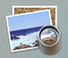
in preview select the toolbox icon
a few options will appear, select the triangle
you will be able to adjust the exposure and contrast

Here are 2 options for great results when working with photos

A.) Import your image in photos
and apply filters to transform your image

When your image has been imported in photos, select this tab
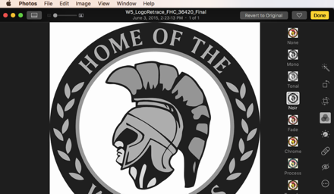
B) Open your image in preview. In preview you have this button 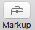 which opens up these options. You can adjust the contrast, cut the image in a shape...

